# MEDICAL EXPENSES by using

**Machine Learning**

**A PROJECT REPORT**

Submitted by: Sujata Mandal

## 



## NATIONAL INSTITUTE OF TECHNOLOGY AGARTALA

***Under the Project Guidance of***

**DHRUBA RAY**

***At***

**Ardent Computech Pvt. Ltd.**



# CERTIFICATE

This is to certify that **AKASH DEB, SOUMYADEEP ROY AND SWARNENDU MAJUMDER** have successfully completed the project titled ***“Medical Expenses Prediction by using machine learning”*** under my supervision during the period from , 2021 to , 2021 which is in fulfillment of their training in Data science and machine learning using python.

**Signature of Mentor**

**Ardent**

**Computech Pvt. Ltd**

**Salt Lake, Kolkata**

# ACKNOWLEDGEMENT

The project ***“Medical Expenses Prediction by using machine learning”*** would not have been possible without the constant guidance of our guide **Dhruba Ray ,** Ardent Computech Pvt. Ltd., who guided us throughout this process. We are immensely thankful to him for his valuable ideas on improvement of the project.

**INDEX**

|  |  |  |
| --- | --- | --- |
| **Sl No** | **Topic** | **Page No** |
| 1. | Abstract | 5 |
| 2. | Introduction | 6 |
| 3. | Problem Definition | 8 |
| 4. | Project Goal | 8 |
| 5. | Methodology | 9 |
| 6. | Project Objective | 11 |
| 7. | Project Workflow | 11 |
| 8. | Project Implementation | 12 |
| 9. | Step-by-Step Working | 14 |
| 10. | Project Limitations | 16 |
| 11. | Future Scope | 17 |
| 12. | Summary | 18 |
| 13. | Bibliography | 19 |

# ABSTRACT

With the emerging increase of medical expenses , there is a strong need for supporting the medical decision making process. In this project we aim to predict how much medical expense a person has.

In this project, Linear Regression is used to predict how much medical expense a person has. Linear Regression are considered as helpful methods for the diagnosis of such expenses.

They, in fact , are probable models which have been proved useful in displaying complex systems and showing the relationships between variables in a graphical way . This project gives us the outcome of how much medical expense a person has.

# INTRODUCTION

**Python** is an interpreted, high-level and general-purpose programming language. Python's design philosophy emphasizes code readability with its notable use of significant whitespace. Its language constructs and object- oriented approach aim to help programmers write clear, logical code for small and large-scale projects

**Machine learning** (**ML**) is the study of computer algorithms that improve automatically through experience.It is seen as a subset of artificial intelligence. Machine learning algorithms build a model based on sample data, known as "training data”, in order to make predictions or decisions without being explicitly programmed to do so.Machine learning algorithms are used in a wide variety of applications, such as email filtering and computer vision, where it is difficult or unfeasible to develop conventional algorithms to perform the needed tasks.

A subset of machine learning is closely related to computational statistics, which focuses on making predictions using computers; but not all machine learning is statistical learning. The study of mathematical optimization delivers methods, theory and application domains to the field of machine learning. Data mining is a related field of study, focusing on exploratory data analysis through unsupervised learning. In its application across business problems, machine learning is also referred to as predictive analytics

Machine learning involves computers discovering how they can perform tasks without being explicitly programmed to do so. It involves computers learning from data provided so that they carry out certain tasks. For simple tasks assigned to computers, it is possible to program algorithms telling the machine how to execute all steps required to solve the problem at hand; on the computer's part, no learning is needed.

**Linear regression** is a statistical model that in its basic form uses a logistic function to model a binary dependent variable, although many more complex extensions exist. In regression analysis, **linear regression** is estimating the parameters of a linear model.

# PROJECT DEFINITION

The main objective of this project is to predict the medical expenses. The purposed work focuses on to predict expenses using probabilistic model of Regression. This integrated technique of classification gives a promising classification results with utmost accuracy rate. For detecting a survey a number of test should be required from the people. But using data mining technique the number of test should be reduced.

# PROJECT GOAL

The goal is to predict how much medical expense a person has. The goal is achieved by using linear regression in machine learning.

## METHODOLOGY

### • Data Selection : 

Data is the foundation for any machine learning project. The job is to find ways and sources of collecting relevant and comprehensive data, interpreting it, and analyzing results with the help of statistical techniques.

### • Data Visualisation: 

A large amount of information represented in graphic form is easier to understand and analyze. Some companies specify that a *data analyst* must know how to create slides, diagrams, charts, and templates.

### • Data cleaning: 

This set of procedures allows for removing noise and fixing inconsistencies in data. A data scientist can fill in missing data using imputation techniques. A specialist also detects outliers — observations that deviate significantly from the rest of distribution.

### • Data Splitting: 

A dataset used for machine learning should be partitioned into three subsets — training, test, and validation sets.

### • Model Selection: 

After a data scientist has preprocessed the collected data and split it into three subsets, he or she can proceed with a model training. This process entails “feeding” the algorithm with training data. An algorithm will process data and output a model that is able to find a target value in new data .The purpose of model training is to develop a model.

### • Model Evaluation: 

The goal of this step is to develop the simplest model able to formulate a target value fast and well enough and check the accuracy .

## PROJECT OBJECTIVE

The main objective of this is to predict how much medical expense a person has using machine learning.

## PROJECT WORKFLOW

This is the detailed work architecture where we are showing the process of Diabetes Prediction using machine learning.

**Data**

**Selection**

**Data**

**Visualization**

**Data**

**Cleaning**

**Data**

**Splitting**

|  |  |  |  |  |
| --- | --- | --- | --- | --- |
| |  | | --- | | **Model**  **Evaluation** | |  | |  | | --- | | **Model Training** | |

## PROJECT IMPLEMENTATION

* SELECTION OF DATA: 

The process of selecting data depends on the type of project we desire to. The data set can be collected from various sources such as a file, database, sensor and many other such sources.

* VISUALIZATION OF DATA: 

Data visualization is the graphical representation of.information and data. By using visual elements like charts, graphs, and maps, data visualization tools provide an accessible way to see and understand trends, outliers, and patterns in .

* DATA PRE-PROCESSING : 

As we know that data pre-processing is a process of cleaning the raw data into clean data, so that can be used to train the model. So, we definitely need data pre-processing to achieve good results from the applied model in machine learning and deep learning projects.

* SELECTION OF DEPENDENT AND INDEPENDENT DATA: We need to select the dependent and independent data and store them in y and x. 
* SPLITTING OF THE DATA: 

We train the classifier using ‘**training data set**’, then test the performance of your classifier on unseen ‘**test data set**’.We split the data for training and testing by using the ‘train_test_split’ .

* FITTING THE MODEL: 

In a data set, a training set is implemented to build up a model.Once the model is trained we can use the same trained model to predict using the testing data

i.e. the unseen data. Once this is done we can develop a confusion matrix, this tells us how well our model is trained.

* MODEL EVALUATION : 

It is an integral part of the model development process. It helps to find the best model that represents our data and how well the chosen model will work in the future.

**STEP BY STEP WORKING:**

* SELECTION OF DATA: 

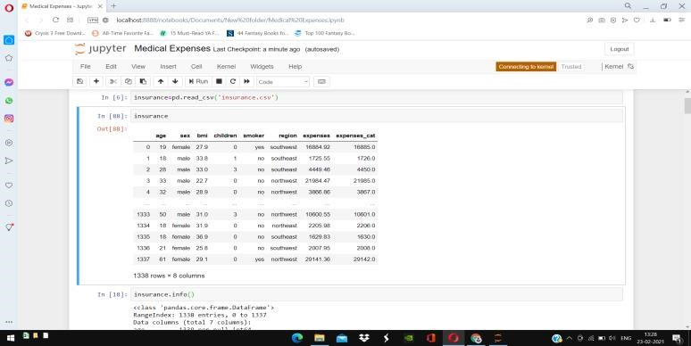

* VISUALIZATION OF DATA: 

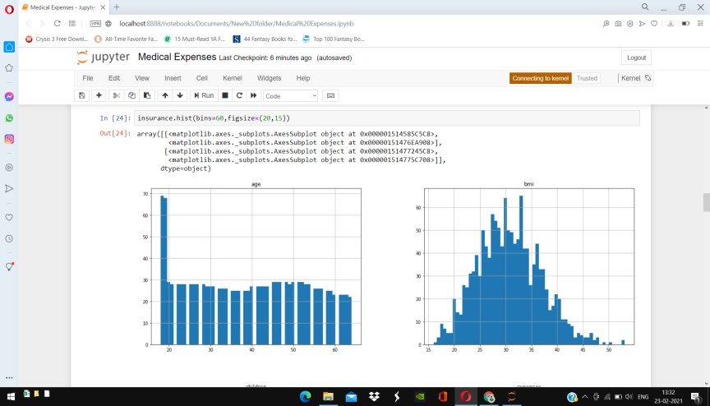

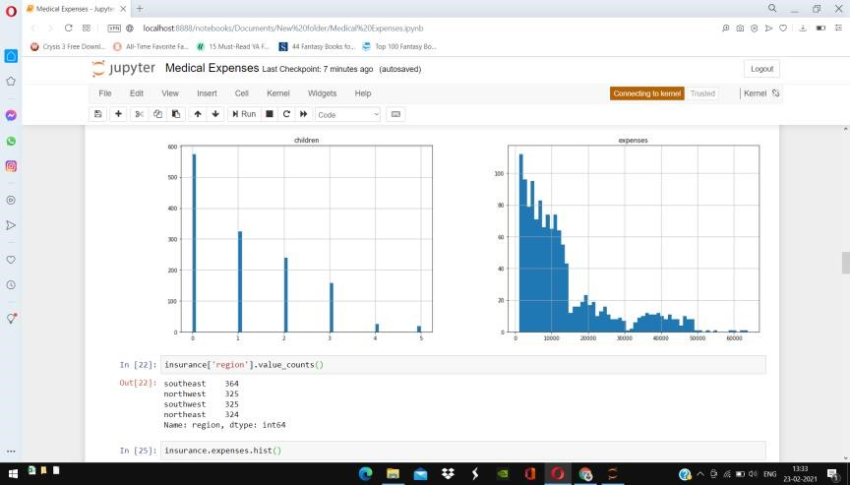

* CLEANING DATA: 

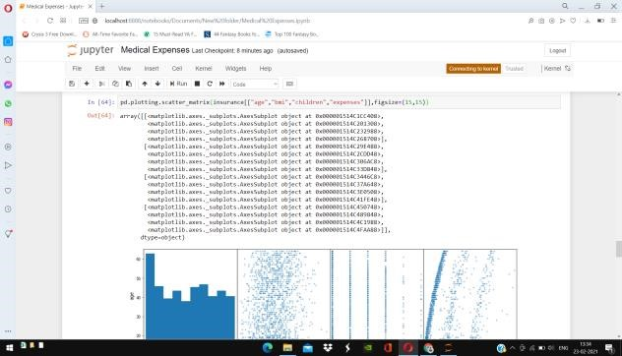

* DEPENDENT AND INDEPENDENT DATA: 

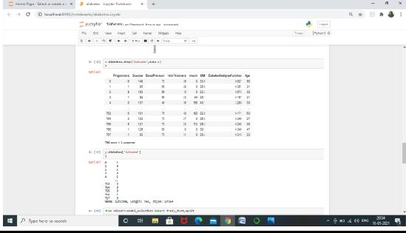

* SPLITTING THE DATA: 

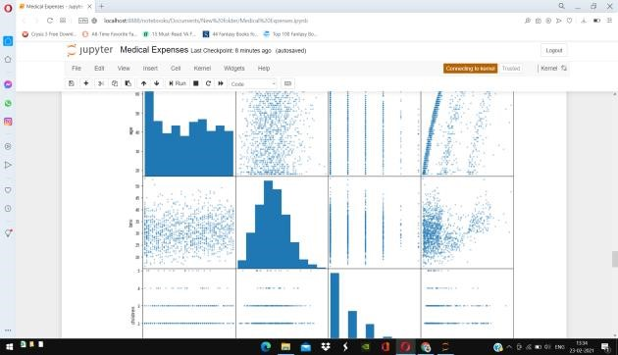

* MODEL TRAINING: 

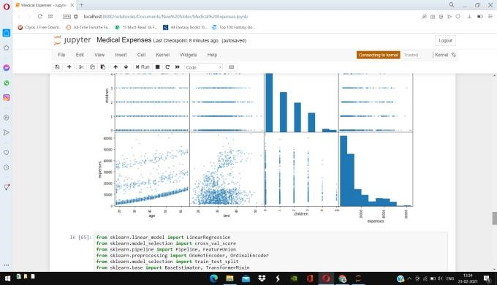

* MODEL EVALUATION: 

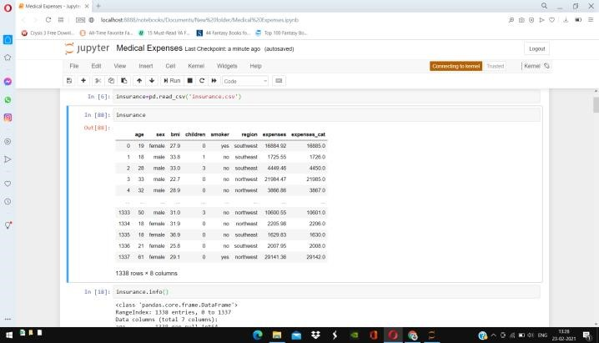

**PROJECT LIMITATIONS:**

* We worked on the **backend part of the system** thus there is no frontend work associated which can result in a more realistic look and focus on user experience.
* While using dataset greater than 1gb , the project won’t work properly.

# FUTURE SCOPE

* Since here only the backend part of the system is built, we can create a custom frontend which can result in a more realistic look and focus on user experience.
* We can work on the project and use it for greater size dataset .

## SUMMARY

We load previous datasets to the system.Visualization of data is done to properly know about the data . Data pre-processing is not required as there was no Nan. Following operations are performed on the dataset after that. User input data to the system in order to diagnose whether he has the disease or not. Building model using Logistic Regression Algorithm and train the data set. Test the dataset using model. Get the evaluation result. Get the predicted voting from all classifiers and gives the diagnostic result.

## BIBLIOGRAPHY

* [*https://www.wikipedia.org/* ](https://www.wikipedia.org/)

* [https://www.altexsoft.com/blog/datascience/machine- learning-project-structure-stages-roles-and-tools/ ](https://www.altexsoft.com/blog/datascience/machine-learning-project-structure-stages-roles-and-tools/)

* [*https://stackify.com/aws-lambda-with-python-a- complete-getting-started-gui de/* ](https://stackify.com/aws-lambda-with-python-a-complete-getting-started-guide/)

* [*https://towardsdatascience.com/workflow-of-a- machine-learning-project-ec1dba419b94* ](https://towardsdatascience.com/workflow-of-a-machine-learning-project-ec1dba419b94)

**CODE**

**import numpy as np import pandas as pd**

**insurance=pd.read_csv('insurance.csv') insurance insurance.info()_ insurance.head() insurance['expenses'].unique() insurance['expenses'].value_counts() insurance['expenses'].value_counts(ascending=True) insurance['expenses'].value_counts().sort_index() insurance['expenses'].value_counts().sort_values() insurance.describe() insurance.hist(bins=60,figsize=(20,15)) insurance['region'].value_counts() insurance.expenses.hist() corr = insurance.corr() corr [["age","bmi","children","expenses"]] corr['expenses'].sort_values(ascending=False) corr['age'].sort_values(ascending**

**=False)**

**corr['bmi'].sort_values(ascending**

**=False)**

**corr['children'].sort_values(ascen ding=False) len(insurance['expenses']) len(np.ceil(insurance['expenses']).unique()) np.max(np.ceil(insurance['expenses']))**

**pd.plotting.scatter_matrix(insurance[["age","bmi","children","expenses"]],figsize**

**=(15,15) from sklearn.linear_model import LinearRegression from sklearn.model_selection import cross_val_score from sklearn.pipeline import Pipeline, FeatureUnion from sklearn.preprocessing import OneHotEncoder, OrdinalEncoder**

**from sklearn.model_selection import train_test_split from sklearn.base import BaseEstimator, TransformerMixin from sklearn.preprocessing import PolynomialFeatures**

**X = insurance.iloc[:, :-1]**

**y = insurance.iloc[:, -1]**

**X.head() y[:5]**

**X_train, X_test, y_train, y_test = train_test_split(X, y, test_size=0.2) class DataframeSelector(BaseEstimator, TransformerMixin): def __init__(self, cols):**

**self.cols = cols def fit(self, X, y=None):**

**return self def transform(self, X, y=None): return X[self.cols].values num_pipe = Pipeline([**

**('selector', DataframeSelector(['age', 'bmi', 'children'])),**

**])**

**cat_pipe = Pipeline([**

**('selector', DataframeSelector(['sex', 'smoker', 'region'])),**

**('hot_encoder', OneHotEncoder(sparse=False))**

**])**

**pipe = FeatureUnion([ ('num_pipe', num_pipe),**

**('cat_pipe', cat_pipe)**

**])**

**X_train_prepared = pipe.fit_transform(X_train)**

**X_train_prepared[:5] lin_reg = LinearRegression()**

**scores = cross_val_score(lin_reg, X_train_prepared, y_train, cv=3,**

**scoring="neg_mean_squared_error") np.sqrt(-scores) lin_reg.fit(X_train_prepared, y_train) y_train_hat = lin_reg.predict(X_train_prepared) from sklearn.metrics import mean_squared_error mean_squared_error(y_train, y_train_hat) X_test_prepared = pipe.fit_transform(X_test) y_test_hat = lin_reg.predict(X_test_prepared) mean_squared_error(y_test, y_test_hat)**